THE ROMAN CATHOLIC PARISH OF ST. JOHN VIANNEY, 21 HEATHFIELD ROAD, BEXLEYHEATH, KENT DA6 8NP
PARISH PRIEST: Fr Michael Jones  Email: michaeljones@rcaos.org.uk  ASSISTANT PRIEST: Fr Luke Malunze  Email: lukemalunze@rcaos.org.uk  PARISH SECRETARY: CATH BIRD  Parish Office Email bexleyheath@rcaos.org.uk  Parish Website: www.StJohnVianney-Bexleyheath.org  Tel: 020 8303 1957 |  | SAFEGUARDING REPRESENTATIVES:  CATH BIRD  Email: bexleyheathsg1@safeguardrcaos.org.uk  Tel: 07927 637425  LENA PETT  Email: bexleyheathsg3@safeguardrcaos.org.uk  Tel: 07927 637424
FOURTH SUNDAY OF ADVENT (YEAR A) – PAGE 90
Sunday 21st December 2025  Fourth Sunday of Advent/  Day of Prayer for Expectant Mothers  08.30 Mass in Thanksgiving and Honour to  Our Lady of Lourdes (Guilbert) (Fr M)  10.30 Mass for Joe Mendes RIP (D’Costa)  (Fr L) Children’s Liturgy  Choir Practice for Christmas after Mass  Refreshments in the hall  17.30 Mass for Mary McGinty RIP (Family)  (Fr M)  Second Collection for flowers for Christmas  Monday 22nd December 2025 Feria  NO Mass  10.00 Decorating of church. Everyone is  welcome  Tuesday 23rd December 2025 Feria  09.00 Mass for Holy Souls with Confession  (Fr L)  Wednesday 24th December 2025 Feria  Christmas Eve  09.00 Mass for Holy Souls with Confession  (Fr L)  THE SEASON OF CHRISTMAS  Christmas Eve  18.00 First Mass of Christmas (especially for  the children)  Mass for Dorothy & Jack Bird RIP  (Fr M)  21.30 Carol Service  22.00 Christmas Night Mass  Mass for Richard Slaney RIP (Fr L)  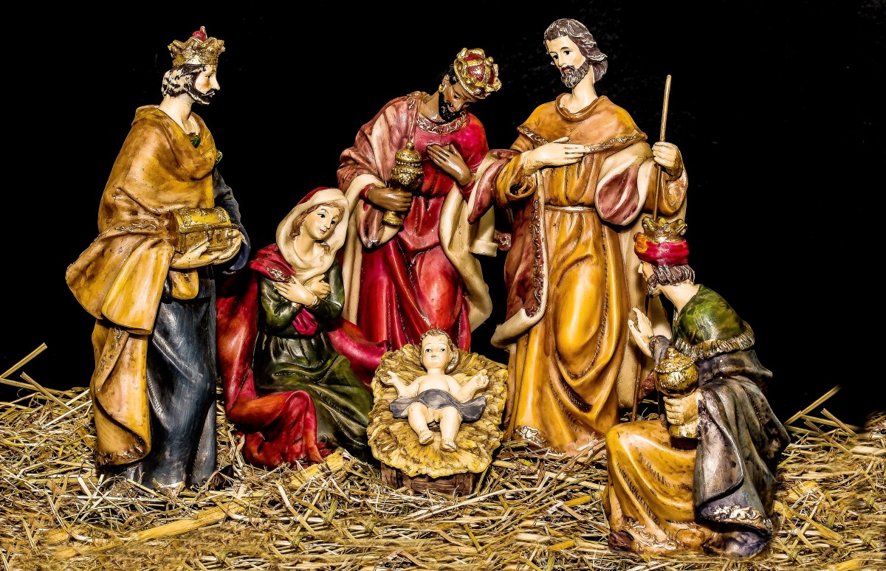  Thursday 25th December 2025  Christmas Day – The Nativity of Our Lord Jesus  09.30 Mass for Parishioners (Fr M/Fr L)  No Evening Mass  Friday 26th December 2025  Feast of St Stephen, Deacon, Martyr  10.00 Mass for Yvette Town-Jones RIP  (D’Costa) (Fr L)  Saturday 27th December 2025  Feast of St John, Apostle and Evangelist  10.00 Mass for Rozzi Cox RIP (Pereira) (Fr L)  Confessions  Sunday 28th December 2025  The Feast of the Holy Family of Jesus, Mary and Joseph  08.30 Mass in Thanksgiving and Honour to  St Jude (Guilbert) (Fr L)  10.30 Mass for Caroline & Mark White RIP  (Keates)  (Fr M) No Children’s Liturgy  No Refreshments  17.30 Mass for Natalie Delvaille-Sills & Family  (Carolan) (Fr L)  Celebration of Birthdays and Anniversaries  Monday 29th December 2025  Fifth Day of Christmas Octave  No Mass  Tuesday 30th December 2025  Sixth Day of Christmas Octave  09.00 Mass for Patsy & Neil Taylor & Family  (Carolan) (Fr L)  Wednesday 31st December 2025  Seventh Day of Christmas Octave  09.00 Mass for Holy Souls (Fr L)  Thursday 1st January 2026  Mary, the Holy Mother of God  New Year’s Day (Bank Holiday)  12.00 Mass to celebrate Kay Offord’s 100th  Birthday (Fr M/Fr L)  Congratulations to Kay: on reaching her 100th birthday. Kay is a woman of immense faith with a great devotion to Our Lord. She attended Our Lady of the Angels for many years until she had to give up driving in her 90s and then started attending St John Vianney Church, walking daily, until this too became difficult. Some of our parishioners kindly bring her to Mass during the week and on a Sunday. Enjoy your celebrations Kay!  Friday 2nd January 2026  Saints Basil & Gregory, Bishops & Doctors  09.00 Mass for Eddie Hensman RIP & Sally  Holland RIP (Hensman) (Fr M)  Adoration until 10.00am  Confessions straight after the Blessed Sacrament is Exposed  Saturday 3rd January 2026  10.00 Mass for Deceased Coroi Family  Members (Fr M)  Confessions  Sunday 4th January 2026  Second Sunday after Christmas  08.30 Mass in Grateful Thanksgiving to St  Jude (Guilbert) (Fr M)  10.30 Mass for Cath & Alan Bird & Family  (Carolan) (Fr M)  Refreshments resume today  17.30 Mass for Nicholas Burke RIP (OLA) | Today the readings always focus on Our Lady as she waits patiently for the birth of her son. For this reason, today is also a day when we pray for expectant mothers everywhere who are also waiting for the birth of their child. We pray that they may have a safe delivery. In Year A we listen to St Matthew’s gospel. In his Nativity account he focusses also on Saint Joseph. Because Mary is pregnant and they had not had intercourse  he is confused and does not know what to do. He knows that there is something supernatural going on. God sends an angelic message via  a dream to reassure him and to tell him that Mary has conceived through the power of the Holy Spirit. We should also pray for fathers who also need support and reassurance.
 | Today there is a retiring collection for the flowers at Christmas.
 | The Jesse Tree: Today the children will be focusing on Mary and the Nativity.
 | Guild of Saint Stephen: On Sunday 28th December during 8.30 and 10.30 Masses, we will enrol some of our altar servers into the Guild of Saint Stephen. There will be a short service after the homily. St Stephen the first deacon and martyr is the patron saint of those who serve at Mass.
 | The Second Part of Advent begins on 17th December when we have special prayers each day as we prepare for the coming of the Saviour. In the Divine Office we say the “O Antiphons” at Vespers. They are addressed to Jesus using various images taken from the Bible and express our longing for the coming of Jesus. The hymn “O Come, O come Emmanuel” contains these Antiphons. For example: O Come thou Dayspring from on high, O Come, thou key of David.
 | Congratulations to Theodore Daniel Sherwood who was baptised last weekend.
Donations of Holly: Now is the time to bring in your donations of holly to enable us to decorate the church. Please put in a black bag and leave in the room where the servers get ready. Thank you.
Poinsettias: As in previous years, we would like donations of Poinsettias in memory of a loved one.
The Christmas Collection: Fr Michael writes: I don’t usually say much about this but now we have two priests I felt I should. This collection goes to your priests. It forms a major part of their income. Priests do not get a salary but rely on the Christmas and Easter Collection, Mass Intentions and donations for funerals, baptisms and marriages (Stole fees). This parish has always had one priest until the past three years. But now we have two. Fr Luke has a small monthly income from the parish (£148) and in addition Mass Stipends. In the past the Christmas collection has been generous enough for one priest but now we need to ask you to be more generous. Every priest is entitled to £3,500 at Christmas and if the collection falls short of this he can claim the remainder. This used to be given by the Diocese but now the parish has to make up the shortfall.
I have never claimed this money. Our expenses with two priests have risen considerably over the past three years with food, heating etc. so can I ask you to bear this in mind when you give your donation at Christmas. With grateful thanks.
 | Christmas Raffle: Thank you to everyone who supported our raffle. We raised £456.71 profit.
 | This Monday we will be decoration the church: We would welcome your help in doing this. Doors will be open from 10.00am.
 | Volunteering at Christmas: It’s not too late to sign up and help at Christmas Eve and Christmas Day. Lists are on the noticeboard in the porch.
 | Readers’ Rotas: January-February 2025: These are available in the porch to collect.
Music Group Appeal – Singers are required for the 6pm Children's Christmas Eve mass, the Carol service/10pm Christmas Mass and the Christmas Day Mass. We will also require readers for all the Christmas masses and the Carol service.
There will be a quick rehearsal after the 10:30am Sunday mass today for singers who will be attending the Carol Service.
Please support your parish. Thank you.
 | The Knights of St Columba will be handing out Christmas Posters after each Mass today.
Children’s Liturgy: Today will be our last class until Sunday
11th January 2026. Thank you to our catechists for spreading God’s Word. We could always do with more volunteers. Please let the parish office know if you would like to help. A DBS form will need to be completed upon application.
 | Radio Maria is a global network of 24-hour Catholic radio stations that broadcast religious programming to support listeners' spiritual lives.https://radiomariaengland.uk/
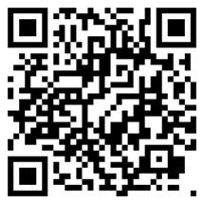
In his annual Christmas message, Archbishop John Wilson said: “The beautiful truth of Christmas is that because of God in Christ we are never lost. God chose to be near us, to stay close to us always, to draw us to himself, always. In his endless mercy, the Lord Jesus chose to love us, so we could know and believe that “God is love” (1 John 4:16). In turn, all the Lord Jesus asks of us is to not be afraid and to say yes to him, to draw close to him, to love him”. You can watch and read the full message at rcaos.org.uk/christmasmessage2025.
 | Carol Services: Last week we were delighted to welcome Years 5 & 6 from Saint Thomas More’s School to our church for their Carol Services. They were very uplifting and enjoyable. The children sang different carols at each service. They sang with power and enthusiasm and the sounds filled the church. The children also read very well. It was a lovely evening. We thank the teachers and children of St Thomas More school for sharing the Christmas story with us. They were a credit to the school. Well done!
 | Catholic Directory 2026: Copies are available to purchase in the porch at a cost of £7.50 each. Please make payment either in the “CTS” wall safe or pay by card at the machine, selecting “Repository”. Thank you
Refreshments: Today will be our last refreshments until Sunday
4th January 2026. Thank you to all the volunteers for supplying hot drinks after 10.30 Mass. Maybe come along and join us in the New Year and get to know parishioners over a cuppa.
Crib Donations: This year, our Crib donations will be going to The Bethlehem Care and Hospice Trust. This Trust was established following a request from Bethlehem Christians for help in establishing a hospice. Please donate via our box by the Crib or go to https://bethlehemcareandhospicetrust.org/. Thank you.
Please pray for the sick and those in special need of your prayers: John Yates, Meta James, Tracey James, Baby Teddy, John Smith, Tom C, Susan, Adelina Braganza, Stelian, Claire Wansbury, Alan and Rene Fisher, Baby Jemima Rita James, Fr Jeff, Shirley Angerer, Josephine Treloar, Jacqueline Downey, Steve Smith, Annie and Gerry McDonagh Snr, Gerry McDonagh Jnr and Martin McDonagh, Keith Smith, Samantha Butler, Carole, Mrs Chris Lynch, Ashleigh, Fr Michael, Kathy Blakemore, Kirsty, Robin Robinson, Alice, John Moore, Pauline Viegas, Deirdre Collins, Susan Dassanyake, Nuala Pawley, Helena Riley, Richard Whiteside, Sally Pain, Florrie Pereira, Jo O’Donnell, Matthew Butler, Nadia Sheehy, Steve Pitt, Little Buster Sprules, David Collison, Christine Edwards, Santana Fernandes, Maria Pereira, Leonie Viegas, Paul Robson, Jack Goodrich, Gloria Slaney, Andy Wansbury,
Josephine da Silva and Roy Miller.
Hiring of Hall: Please contact Cath Bird: 07989 156111 or email: bexleyheath@rcaos.org.uk
Receiving the newsletter online: In order to reduce paper wastage, if you would like to have our weekly newsletter emailed to you, please contact the parish office bexleyheath@rcaos.org.uk and it will be sent to you weekly.
HOW TO MAKE YOUR OFFERTORY DONATION: Donations for the Offertory Collection can be made in the usual way via the basket. Alternatively, you can donate via BACs to our bank account (details below). Payments can be made for Masses this way too. You can also make payments via our card machine, located in the porch. You can also pay for Repository items, Second Collections and Candles via this method too. Please remember to Gift Aid if you are tax payer. Payment online: Account No: 21089620 Sort Code: 51-70-14 Account Name: RCAS Bexleyheath
EVERYONE IS WELCOME... to become a welcomer at one of the three Sunday Masses. The more people who volunteer will enable us to start a rota and consequently the more people on the rota means there are fewer times you have to do it. The parish needs you to help it continue to grow and for Father Michael and Father Luke to provide you with Spiritual help and guidance. Support your parish. It needs you.
Counters needed for Offertory Collections: We need some more volunteers to come and help count the weekly collection, usually on a Tuesday morning. If you feel you could help, please email bexleyheath@rcaos.org.uk or speak to either Fr Michael or Fr Luke. Thank you in advance.
St Thomas More Catholic Primary School’s last Open Morning is on Tuesday 13th January 2026 at 9.30am.
Job Vacancy – CriBS School Worker: See poster on noticeboard. If you have any questions or would like further information, please email slt@cribsonline.org
Donations for Local Foodbanks: We have now resumed collecting donations for the foodbanks. Items needed are cereal, sugar, tea, coffee, UHT milk, toilet rolls, tinned meat, tinned vegetables, tinned fruit, soup etc. We’ve also been made aware that hats and gloves are in urgent need too, so if you could supply these also, it would be greatly appreciated. Thank you for supporting this.
Wintertime 2026: Friday 2nd-Sunday 4th January: Cost £139: For aged 11-15. This initiative is an offshoot of Summertime 2025.
For altars servers and those who attend Sunday mass regularly aged 11-15. See poster for details. Forms will be available, or you can contact Fr. Stephen Boyle, dartford@rcaos.org.uk. It takes place at Westminster Pastoral centre, Pinner. Names need to be known by 15th December, and forms received by Fr. Stephen Boyle by the 20th December. There are limited numbers, so we recommend booking early to book a place. A coach will be put on from St. Anselm’s Dartford at a cost of £20 return.
Retrouvaille helps marriages. It can bring hope and healing to relationships. Next date: 12th February 2026. www.retrouvaille.org.uk Tel: 07887 296983
MASSES AT CHRISTMAS
Christmas Eve: 6.00pm First Mass of Christmas (especially for children) (Fr M)
9.30pm Carol Service & 10.00pm Christmas Night Mass (Fr L)
Christmas Day: 9.30am The Nativity of Our Lord Jesus Christ (Fr M/Fr L)
Please note there is no Midnight Mass on Christmas Eve and no evening Mass on Christmas Day. Please ensure you take a copy of the Christmas Programme.
Children are encouraged to dress up for the 6.00pm Mass on Christmas Eve as Mary, Joseph, Shepherds, Sheep, Angels, Stars and not forgetting a Donkey!
Fr Luke will be away to visit his family in Nigeria from 1st January until 4th February. Fr Michael will be on his own and will try to say Mass on Fridays, Saturdays and Sunday 8.30 & 10.30. One of the priests from Erith will celebrate the 5.30pm Mass. There will be Services of the Word with Holy Communion on a couple of weekdays but watch the newsletter for these. There are no baptisms during January. If we have funerals with burials the local priests of the Deanery have shown their willingness to help. The 6th January is the Solemnity of the Epiphany and a Holyday of Obligation. We will have Mass here at 10.00am but no evening Mass. Fr Michael writes: please God I don’t fall ill or fall over during January. We also have the First Communion Programme starting. Another point: I wear an alarm in case I fall over. When it goes off or I press it the Care team have a list of contacts. Fr Luke is on that list but will not be here. Is there someone who lives nearby who could join Cath and Maura on the list? I am praying we do not have ice to deal with!
WITH THE FLU VIRUS GOING ABOUT, PLEASE ENSURE YOU SANITISE YOUR HANDS UPON ENTERING AND LEAVING CHURCH.

